Browser Compatibility Test

This testing method is about test the web application in different browsers for ensuring that the system runs in every browser without any issues.

|  |  |  |  |  |  |
| --- | --- | --- | --- | --- | --- |
| **No** | **Title** | **Pre-Condition** | **Test Steps** | **Expected Result** | **Actual Result** |
| 6.1 | Browser Compatibility Test | Logged in from chrome | Run the system Chrome | Runs from chrome browser without any issues | works perfectly |
| 6.2 | Browser compatibility Test | Logged in from Mozilla Firefox | Run the system Mozilla Firefox | Runs without any issues | Working perfectly |
| 6.3 | Browser compatibility Test | Logged in for Internet Explorer | Run the system Internet Explorer | Runs without any issues | Working perfectly |

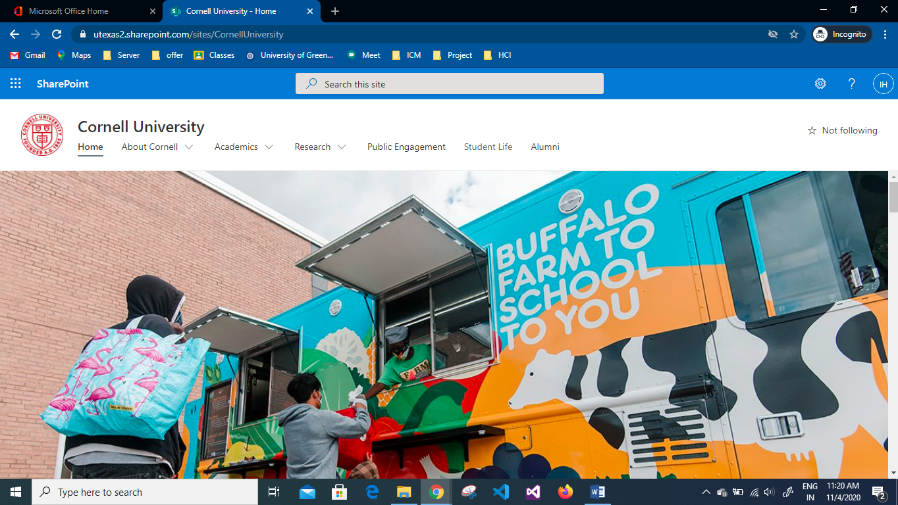

Figure : Home page of the system in google chrome.



Figure : Showing in Mozilla Firefox



Figure : Internet Explorer